March 12, 2015

Betsy Harris
Harold Young Inc.
1 Tech Circle
Natick, MA 01760

Dear Betsy:

As you aware, Harold Young Inc. was appointed in June 2013 to represent Bumble Bee Seafoods at BJ’s for SuperFresh “Project Maggie”, our line of frozen value added products under the SuperFresh trademark. These products all bare Bumble Bee Seafood’s UPC codes.

Since this appointment, Bumble Bee completed a transaction with Anova who has launched a lineup of SKUs also under the SuperFresh brand. These SKUs are not covered under your agreement and are as follows:

86600 90040 – SuperFresh 2LB ULT AHI TUNA CLUB PACK
86600 90051 – SuperFresh 2LB ULT ALBACORE TUNA CLUB PACK
86600 90054 – SuperFresh 18OZ ULT SEARED AHI TUNA

While these SKUs are not part of the agreement, you are still appointed to represent Bumble Bee Seafoods SuperFresh as indicated in our original agreement from June 2013.

Please let me know of any questions that you may have regarding this matter.

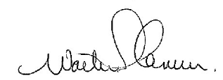
Sincerely,

Scott Cameron
SVP US Sales
Bumble Bee Seafoods

